- Simplify: + -
- + (b). - (c) + (d). -
- Evaluate:
(a). 121 (b). 144 (c) 169 (d). 196
- Given that y varies inversely as the square of x. if x=3 when y=100, find the equation connecting x and y
- yx2=300 (b). yx2=900 (c) yx2= (d) y = 900x2
- find the value of for which 32four = 22
(a). three (b) five (c) Six (d) seven
- Simplify:
(a). (b) (c) (d)
- There are 250 boys and 150 girls in a school. If 60% of the boys and 40% of the girls play football. What percentage of the school play football?
(a). 40.0% (b) 42.2% (c) 50.0% (d) 52.5%
- If log10 (6 – log10 2=1, solve for
(a). 2 (b) 3 (c) 4 (d) 5
- If F = C + 32, find C when F = 98.6
- 30 (b) 37 (c) 39 (d) 41
- If 2 = 4 and find the value of (.
- 3 (b) 2 (c) 1 (d) -1
- If Evaluate .
- (b) 2 (c) (d)
- Simplify:
- 2(1+3m) (b) 2(2+3m2) (c) 2(1-3m) (d) 2(1-3m2)
- A curve is such that when = 0, = -2 or =3. Find the equation for the curve.
(a). =-5-6 (b). = (c) =(d) =--6
- The volume of a cylindrical tank, 10m high is 385m3. Find the diameter of the tank. Take
(a). 14(b). 10 (c). 7 (d). 5
- The surface of a sphere is . Find correct to nearest whole number, its volume. Take
- 113 (b) (c) (d)
- A piece of thread of length 21.4cm is used to form a sector of a circle of radius 4.2cm on a piece of cloth. Calculate, correct to the nearest degree, the angle of the sector. Take
- 1700 (b) 1770 (c) 1820 (d) 1920
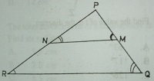

In the diagram which of the following ratios is equal to
- (b). (c) (d)
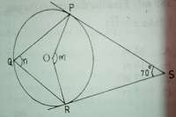

In the diagram PS and RS are tangents to the circle centre O, <PSR = 700, <POR = m and <PQR = n. Find (m+n).
- 1100 (b) 1350 (c) 1650 (d) 2250
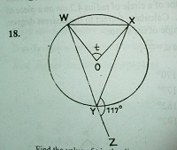

Find the value of t in the diagram
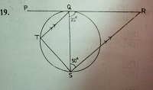
- 630 (b) 1170 (c) 1260 (d) 2340

In the diagram, PR is a tangent to the circle at Q, QT//RS, <SQR = 350 and <RSQ = 500. Find the value of <QST.
- 400 (b) 650 (c) 85 (d) 950
- The angles of a polygon are , 2, 2+300), (+200) and (-100). Find the value of .
- 450 (b) 840 (c) 850 (d) 950
- If M and N are the points (-3, 8) and (5, -7) respectively, find .
- 8 units (b) 11 units (c) 15 units (d) 17 units
- The equation of the line through the points (4, 2) and (-8, -2) is 3 = p + q, where and are constants. Find the value of .
- 1 (b) 2 c) 3 (d) 9

- The angle of elevation of the top of a tree from a point 27 away and on the same horizontal ground as the foot of the tree is 300. Find the height of the tree.
- 27 (b) 13.5 (c) 13.5 (d)
- If tan =, 00 <0, find the value of sin - cos.
- (b) (c) (d)
- Given that is 20 on a bearing of 3000 from , how far south of is ?
- 10 (b) 15 (c) 25 (d) 30
- The mean of 1,3,5,7 and is 4. Find the value of
- 2 (b) 4 (c) 6 (d) 8

- Find the median of 2,1,0,3,1,14,0,1 and 2.
- 0.0 (b) 0.5 (c) 1.0 (d)1.5
Number of goals | 1 | 2 | 3 | 4 | 5 | 6 | 7
Number of teams | 3 | 1 | 6 | 6 | 4 | 2 | 3
The table shows the distributions of goals scored by 25 teams in a football competition. Use it to answer questions 28 and 29.
- Calculate the probability that a team selected at random scored at most 3 goals.
- (b) (c) (d)
- Find the probability that a team selected at random scored either 4 or 7 goals.
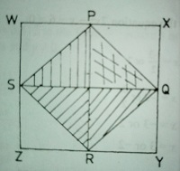
- (b) (c) (d)

In the diagram, WXYZ, is a rectangle with dimension 8cm by 6cm, P, Q, R and S are the midpoints of the sides of the rectangle as shown. Use this information to answer the questions 30 and 31.
- What type of quadrilateral is the shaded region?
- Trapezium (b) Prism (c) Rectangle (d) Rhombus
- Calculate the area of the part of the rectangle that is not shaded.
- 25 (b) 24 (c) 16 (d) 12
- The total surface area of a hemisphere is 75 . Find its radius
- 5.0 (b) 7.0 (c) 8.5 (d) 12.0
- Find the values of for which is
- 0 or 5 (b) -5 or 5 (c) -1 or 5 (d) 0 or 1
- Solve the equation 2x2 --6=0.
- = of 2 (b) (c) (d)
- Factorize completely the expression (+2)2 – (2+1)2
- (3+2)(1-) (b) (3+2)(1-) (c) (3+2)2 (d) 3(+1)(1-)

- Find the nth term of the sequence 2 x 3, 4 x 6
- 2n x 3(n + 1) (b) 2n x 3n (c) 2n x 3n (d) 2n x 3n-1
- If 3 = 4 (mod 5), find the least value of
- 1 (b) 2 (c) 3 (d) 4

- The solution of + 2 2 + 1 is illustrated on the number line as

If p and q are two statements, under what condition would p – q be false?
- If p is true and q is true
- If p is true and q is false
- If p is false and q is false
- If p is false and q is true
- The diagram shows a trapezium inscribed in a semi-circle. If O is mid-point of WZ and = = , calculate the value of
- 900 (b) 600 (c) 450 (d) 300
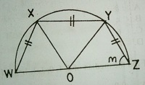

- Find the inter-quartile range of 1,3,4,5,8,9,10,11,12,14,16
- 6 (b) 7 (c) 8 (d) 9
- Donations during the launching of a church project were sent in sealed envelopes. The table shows the distribution of the amount of money in the envelopes.

No. of envelopes | 4 | 7 | 20 | 9 | 4 | 5 | 3 | 1 | 2
Number of teams | 5000 | 2000 | 1000 | 700 | 500 | 100 | 50 | 2 | 10

How much was the total donation?
- N26,792.00 (b) N26,972.00 (c) N62,792.00 (d) N62,972.00

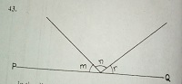

In the diagram, PQ is a straight line, (m+n)=1100, (n+r) = 1300 and (m+r)= 1200, find the ratio of m:n:r.
- 2:3:4 (b) 3:4:5 (c) 4:5:6 (d) 5:6:7
- If := : and := :, find :
- 2:3 (b) 3:4 (c) 3:8 (d) 1:2
- Find the mean deviation of 20, 30, 25, 40, 35, 50, 45, 40, 20 and 45.
- 8 (b) 9 (c) 10 (d) 10
- M and N are two subsets of the universal set (U). if n(U)=48, n(M)=20, n(N)=30 and n(MUN)=40, find n(MՈN)’.
- 18 (b) 20 (c) 30 (d)38
- Express 0.612 in the form , where and are integers and .
- (b) (c) (d)
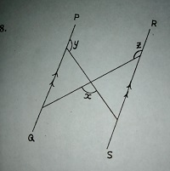

In the diagram, PQ//RS. Find in terms of and .
- =2400 +- (b) =1800 +- (c) =3600 +- (d) =3600--
- The diagonals of a rhombus WXYZ intersect at M. if = 5 = 5, calculate its perimeter.
- 42 (b) (c) 52 (d) 60
- The graphs of =2 and = intersect at which of these points?
- (0,0), (1,1) (b) 0,0), (0,1) (c) (1,0)(0,0) (d) (0,0)(0,0)

